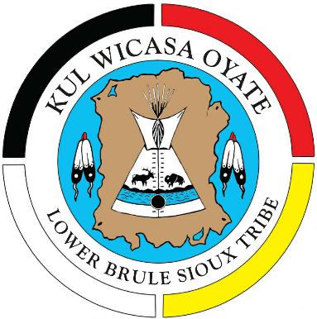

Lower Brule Sioux Tribe
Chairmen 1938-Present
- Reuben Estes - 1938-1942
- Moses Desmet – 1942-1944
- Harvey Big Eagle – 1944-1946
- Thomas Eagle Thunder – 1946-1948
- Richard J LaRoche, Sr. – 1948-1952
- Moses Desmet – 1952-1954
- Clarence Thompson Sr. – 1954-1956
- Joseph “Jiggs” Thompson – 1956-1962
- Richard J LaRoche Jr. – 1962-1964
- Richard Thompson – 1964-1968
- Andrew R. Estes – 1968-1972
- Orville Langdeau Sr. – 1972-1974
- Michael B Jandreau – 1974-1976
- Richard Thompson – 1976-1978
- Michael B Jandreau – 1978-1980
- Orville Langdeau Sr. – 1980-1982
- Patrick Spears – 1982-1984
- Michael B Jandreau – 1984-2015
- Boyd Gourneau – 2016-2020
- Clyde Estes 2020-Present

MBJ Passed April 2015
Boyd G elected at next regular election

